Dear Reader,
From 2005-2007, I was a member of the University of Minnesota Marching Band, also know as “The Pride of Minnesota”; joining the band was, hands down, the best decision I made in college. The clarinets were my best friends, my second family, my shoulders to cry on and I couldn’t have asked for a greater group of people. Many people have called me a band geek and I’ve embraced my geekiness with open arms and a willing heart. Almost all my college memories center around band friends and I couldn’t ask for a better family in college.

GILB (God I Love Band),
Anna Johnson
The University of Minnesota Marching Band, also know now as “The Pride of Minnesota”, was founded in 1892 known then as the University Cadet Band. This group had only 29 members, in stark contrast to the 312 member ensemble that marched in the 2008 season. In 1910 the first formations and halftime show occurred including the very first “Block M” that is now a symbol of the University.

In 1918 the local Army band merged with the Cadet Band to form the First Regiment of Minnesota band; women were not allowed in the marching band at this time but filled in during World War II (1943-46). A “Girls’ Band” was formed in 1950 and women were admitted as full members to the Football Marching Band in 1972

Between 1892 and 2006, the Marching Band has had 18 directors. Neville Staughton was the first director in 1892; Gerald R. Prescott was the first full-time director of the football band in 1932. Dr. Tim Diem has been the director since 2005 and will be leading the Pride of Minnesota as they make their transition into the new TCF Bank Stadium

There have been 58 Drum Majors in the history of the Minnesota Marching Band, with a major milestone in 2006 with the first female drum major, Molly Waters. The current Drum Major is Aaron Marks, who continues his leadership of the band as they march into the future at the new stadium.

Each year, the Indoor Concert is performed at Northrop Memorial Auditorium. These Indoor Concerts were the first of their kind in the country, started by Minnesota’s own Dr. Frank Bencriscutto in the 1960s. 2008 marked the last year the Indoor Concerts will be held in Northrop and the 2009 location is till undecided.

TCF Bank Stadium will be the new home of the Pride of Minnesota starting in August 2009. Leaving the Metrodome behind brings Minnesota football back to campus after over 28 years and provides a much improved home for the band. The Minnesota Marching Band will have much improved practice facilities, locker rooms, rehearsal spaces and offices for the directors.

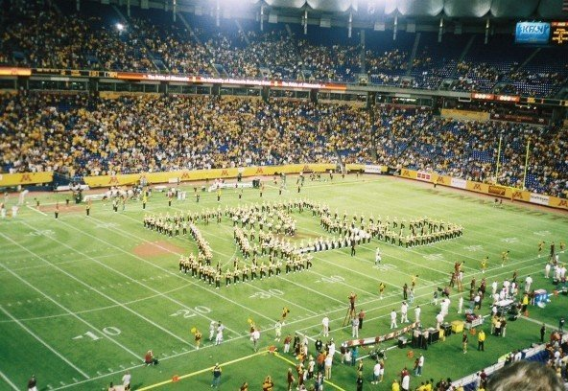

Listen here and follow along
Minnesota Rouser
By Floyd M. Hutsell, Arranged by "Red" McLeod/Frank Bencriscutto

Minnesota, Hats off to thee!
To thy colors, true we shall ever be,
Firm and strong, united are we.
Rah! Rah! Rah! for Ski-U-Mah,
Rah! Rah! Rah! Rah! Rah for the U of M.
[Repeat]
M - I - N - N - E - S - O - T - A!
Minnesota!
Minnesota!
Heeeeeeey Gophers!

"When the University of Minnesota band strikes up the Rouser, I jump to my feet and am twenty years old again. It's pure reflex. These kids think they're playing a march but when they're older they'll understand. It's not just a march, it's youth, passion, color, courage, the joy of life, and most of all it's Minnesota."
-Garrison Keillor

To Whom It May Concern:
As a former member of the UofM Marching Band and an alumna of the university, I find it absolutely appalling that students sit down during the Minnesota Rouser. Sitting during the Rouser is like not standing and taking off your hat for the Star Spangled Banner—it shouldn’t ever happen. The song lasts one minute and 30 seconds (at the most) and represents the spirit and enthusiasm at this university. As a band member I saw firsthand the Football team’s loss to Wisconsin in 2005 and their win against Iowa in 2006; we play the Rouser no matter what, if we win or if we lose. Yes, it’s hard to play the Rouser with much enthusiasm when you’re down 55 points but that’s why the song was written--to inspire fans and athletes, to remind them that the fans are still supporting them when they spell out M-I-N-N-E-S-O-T-A! You don’t have to know the words but please, I beg you, stand up and support your University through something as simple as clapping during the Rouser. Rah!
-Anna Johnson
Game Day

Game day, white shirt, shorts
Warm up, stretch, legs, arms, body
Three, four UP! Rear!
Step, go eight. LINE! Rear, close and down!
Horns up. Minn March down the field
Rah, rah, ski-u-mah, rah, rah, rah rear close and down!
Watch that diag! Get your knees up!
Bones, tones, drums in lines
Hat, plume, gloves, spats
Hem those pants, iron that sleeve, fix that wing
Min! Nah! So! Tah!

A Typical Saturday
5:00am Wake Up
5:30am Walk to Practice
6:00am Stretch
6:30am Line up for Pregame run through
8:00am Eat food
8:30am Dress in uniform
9:00am Inspection
9:30am Ride the bus to the Dome
10:00 am Parade march to the Dome
10:30 am Chair step Pregame
11:00am Kick off
12:30pm Low step Halftime
2:00pm Celebrate a Gopher win
2:15pm Play Postgame
3:00pm Sit, exhausted, on the bus
4:00pm And down
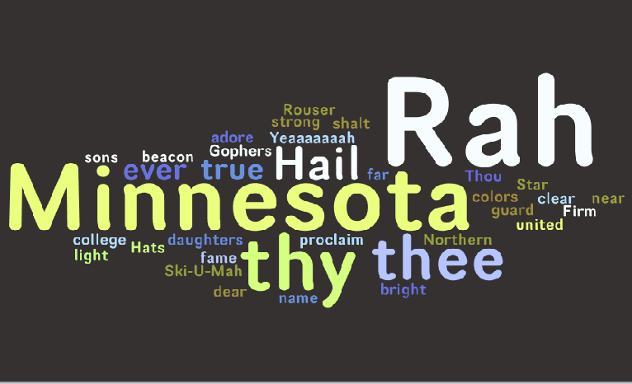
(Created at www.wordle.net )

Listen here and follow along
Hail! Minnesota
By Truman E. Rickard, Arranged by Frank Bencriscutto, Words by Arthur Upson

Minnesota, Hail to thee!
Hail to thee, our college dear!
Thy light shall ever be
A beacon bright and clear/
Thy sons and daughters true
Will proclaim thee near and far.
They will guard thy fame, and adore thy name;
Thou shalt be their Northern Star!

August 25, 2005
Day three. Stand in between Will and Chris. Arms around each other. Feels uncomfortable. Room full of people I don’t know. Lost in the crowd of 300 people. Feel insignificant. Sunburned face turned toward Diem standing on the podium. Hear three notes on the trumpet. Hope I remember the words. Sing Hail! Minn. Remember the words. Get goose bumps from hearing the voices sing together. See seniors singing loud proud. Looks like nothing could please them more than to sing. To sing with their friends, their family. Sense the importance. Convergence of emotions into this one song. Can’t explain the sudden sadness. Move my arms back to my body. Pick up my clarinet. Belonging. It will never be the same again.

November 17, 2007
Tears streaming down my face, blurring my visions. So choked up I can barely play. Gripping Clarissa’s arm for support. Swaying with the other clarinet seniors forgetting the notes to Hail!Minn. Diem standing on the ladder. Can’t believe he’s here at my last game. Smile on his face telling me, without words, how much he missed us. Sobs and hugs smear together to bring comfort, comfort of a family; a group that understands each other. Pride and love surge through my body. Walk down the stairs to the field. Almost over. Cannot believe how far I’ve come since that first Spat camp. Look behind me. See other faces as blotchy as mine, smiling through those tears. Hugs from friends, friends with red noses and wet eyes.
Play “My Way”. Put down my clarinet. Put my arms around Emily and Lizzy. Hear three notes on a trumpet. Hum my pitch. Sing Hail! Minn for the last time at the Dome. Tears pool in my eyes. Dribble down my cheeks. Last time at the Dome. Last time under the marshmallow roof. Last time with the big ladder. Link arms with Clarissa, Jessi and Christina. Walk out of the tunnel into the late afternoon, the November chill contrasting the temperate Dome. Blink three times—it will never be the same again.
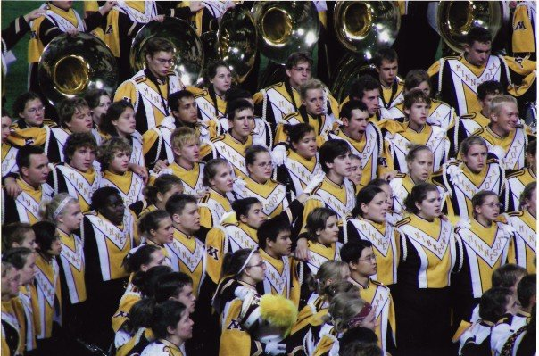
My Band family singing Hail!Minn

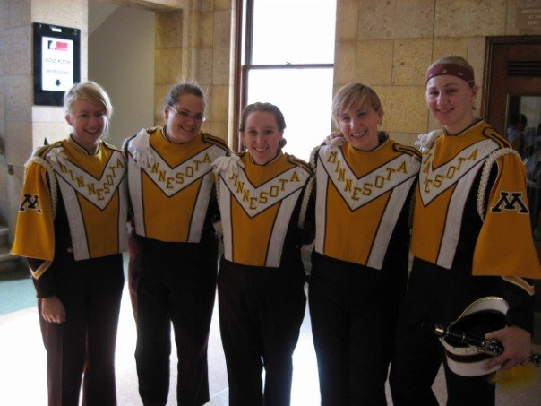
My best Clarinet girls: Christina, Rissa, Me, Jessi, Mar

